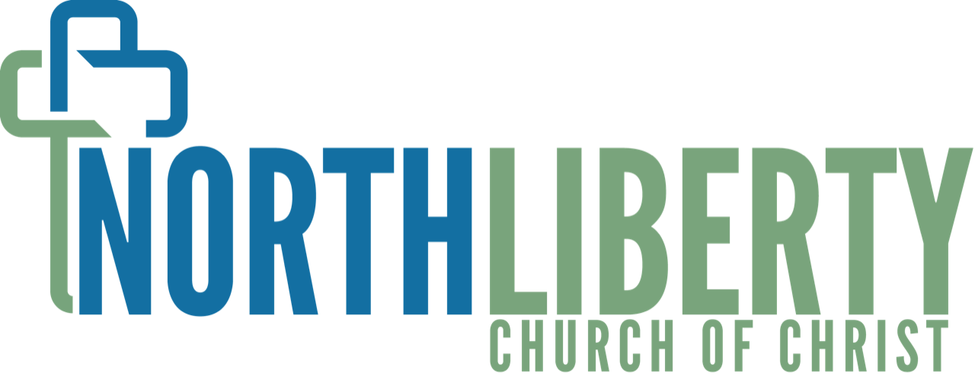

Lead Pastor Job Description
Full-time (43 hours per week)
northliberty.cc

NLCC is a Restoration Christian Church started in the early 1900’s and has since become a mainstay in North Liberty, Indiana and its surrounding communities. NLCC exists to inspire people to experience the transforming power of God through our core values.

Core Responsibilities
1. Spiritual Leader
- Primary speaker for weekend services.
- Responsible for determining and driving the spiritual teaching of the church, including; planning sermon series, delegating speakers appropriately, leading the overall spiritual growth of the congregation.

2. Vision Caster
- Work with and encourage the staff, elders, and congregation to drive the vision of NLCC through teaching, ministries, and church functions.

3. Create Culture
- Foster a culture among staff and elders that encourages camaraderie, character, and a passion for all aspects of ministry.
- Foster a culture among the congregation of worship, fellowship, and service.
- Be an example of and drive the core values of NLCC.

4. Pastoral Care
- Funerals, weddings, baptisms, hospital visits, pastoral counseling, etc.

Qualifications:
- Bachelor's degree in Christian Ministry or related (preferred)
- At least 5 years full time ministry experience

Staff members of NLCC are in very visible positions representing Christ and His church. As such, all staff members are expected to conduct themselves with utmost integrity at all times inside and outside of the workplace, bringing honor and glory to God the Father and respect and confidence to the Church.

